Alcohol Outlets and Violent Crime
Robert Bergeson, Nicole Calvino, Sitaram Sandin & Sarah Smith
Humboldt State University

Abstract
The purpose of this research is to look at incidents of violent crime around on-sale and off-sale alcohol outlets in Fortuna and Arcata, two cities located within Humboldt County, California. Data on violent crime was gathered from both the Arcata and Fortuna police departments and then geocoded. Data on alcohol outlets was gathered from the California Department of Alcoholic Beverage Control and also geocoded. The geographical information systems program, ArcMap®, was used to create maps that show instances of crime in relation to alcohol outlets.
The initial research indicates that there may be a correlation between alcohol outlets and instances of violent crime. In both Arcata and Fortuna, it seems that violent crime occurs more often around areas where alcohol outlets are located. The research is consistent with other studies that have looked at the correlation between violent crime and alcohol outlets. However, more research is needed on this topic as the majority of it has been completed in urban areas. Statistical conclusions cannot be collected due to the nature of the data employed in this study . The research could potentially be used to drive policy around the number of alcohol permits issued in communities, the hours that alcohol outlets are open, and the pricing of alcohol.

Introduction and Literature Review
According to the Center for Disease Control and Prevention (CDC), excessive alcohol use can increase the likelihood of violence and injuries such as falls, drowning, homicide, suicide, intimate partner violence, and sexual assault (Shimotsu, Jones-Webb, Nelson, MacLehose, 2012). When analyzing neighborhood crime, alcohol outlets are a clear spatial signature and thus can be measured by geospatial analysis, using a Geographic Information System (GIS) (Gorman, Gruenewald & Waller, 2013). A literature review conducted by Fitterer, Nelson and Stockwell (2015) found that of the 87 studies relevant to this topic 70 used GIS to conduct this geospatial analysis. These studies have established that there are strong correlations between the rates of violent crime and alcohol outlet density. Although there is existing literature available examining rural areas and the state of California, there is a dearth of research on crime and alcohol outlets that specifically examines Humboldt County. Research that examines the variables of alcohol outlets and violent crime could result in effective policy ramifications.
Minimally intensive policy changes such as a one percent increase in alcohol price, one hour change in closing time, or limitations on alcohol outlet density were found to have substantial reductions on crime rate (Fitterer, Nelson, & Stockwell, 2015). Even when adjusting for potential confounding variables such as neighborhood disadvantage, percent minority, percent occupancy, drug arrests, and spatial dependence, studies such as Jennings, Milam, Greiner, Furr-Holden, Curriero, and Thornton (2014) assessed their models and continued to find a significant association between violent crime in alcohol outlet density. Several longitudinal studies have also found data that increases the strength of the causal relationship between these two factors. Zhang, Hatcher, Clarkson, Holt, Bagchi, Kanny, and Brewer (2015) found that violent crime was two to five times less likely by merely reducing alcohol outlet density in an Atlanta, Georgia neighborhood by three percent. However, the research was focused on a small affluent neighborhood in Atlanta, and it was particularly chosen for having higher density of alcohol outlets.
In contrast, a study conducted in Norfolk, Virginia characterized their city as an average to moderately large size city. These researchers also found that one of the stronger predictive factors of crime rates a neighborhood was the amount of alcohol availability. However, this predictive model did not apply to the downtown area, perhaps because in this area, alcohol outlets are primarily restaurants where people are not going specifically to drink. This study did add to the literature that alcohol outlet density is a factor distinct from neighborhood demographics (White, Gainey, & Triplett, 2015).
When evaluating an urban environment, there is a question as to how high a density of alcohol outlets needs to be in order to measure an increase in assaultive violence. Livingston’s nonlinear mathematical models found that there is little difference in the number of assaults between “zero and 25 licenses and a sharp increase between 30 and 42” (Livingston, p.25, 2008). Due to the socioeconomic characteristics of both Fortuna and Arcata, the results may not be entirely comparable.
Day, Breetzke, Kingham and Campbell (2012) examined data pertaining to New Zealand, which is characterized as large and rural in nature. It found that there is a direct negative correlation between the distance away from an alcohol outlet and the rate of violent crime. As the distance decreased to an alcohol outlet, violent crime went up. This is true for both on-sale and off-sale alcohol outlets, although the effect was more pronounced in on-sale outlets (Day, et. al, 2012).
Researchers in Cincinnati, Ohio further found associations between the types of off premise outlets, such as convenience stores and gas stations and assaultive violence (Pridemore, Grubesic, 2013). However, as California has characteristics unique to its state, it is helpful to narrow the focus to research completed in California. Gruenewald et. al (2006) found in their analysis of 1637 different zip codes in the state that alcohol outlets directly heighten the potentials for violence for all communities that are already prone to have violent crime. The article concluded that both on-sale alcohol outlets and off-sale alcohol outlets have an impact, although this is especially true for bars and taverns (Gruenewald, Freisthler, Remer, LaScala & Treno, 2006). The study did not just focus on urban areas, but various zip codes throughout the entire state of California, and found that this trend was consistent. The authors also found that in rural majority area zip codes in California county, violence was far more common. However, due to unique population demographics specific to Humboldt county, it is not uniformly rural or urban (Gruenewald, et. al, 2006). We therefore compiled a preliminary study to see if these state and national trends are consistent in Humboldt County as well.
Implications for Rural Counties
Understanding alcohol use and violent crime in rural areas is a complicated task. Rural areas are varied in their demographics thus making wide blanket statements difficult to state. It is also difficult to define what a “rural” area is. There are over two dozen different definitions of rural used by the federal government. Out of these there are two main definitions to consider. A rural area can be that which is not a metropolitan or a micropolitan area, or it can be just that which is not a metropolitan area. A micropolitan area is defined as an area between 10,000-50,000 people (Dixon & Chartier, 2016). By this standard, Humboldt county would be considered a micropolitan area, since it has multiple towns in it within this population density. Thus, we will include micropolitan in our definition of rural.
Much of the research pertaining to the relationship between alcohol availability and violent crime has been studied in large metropolitan areas. There is a need for rural areas in general to have this information, as well as for Humboldt county specifically. There has been research showing that both alcohol use (Redwood Memorial Hospital, 2014) and violent crime (Federal Bureau of Investigations [FBI], 2017) are pressing issues for Humboldt County, however, there has not been much research into the effect of alcohol outlets on violent crime specifically. Although the research conducted by Gruenewald et. al (2006) did cover Humboldt County, it was based on a very specific criteria of hospital discharges from the year 2000. It also did not consider an in depth analysis, and it only looked at larger regions within the county rather than looking at specific alcohol outlet clusters within the various cities.
Methods
The purpose of this study was to examine the relationship between instances of violent crime and alcohol outlets within specific areas of Humboldt County. Researchers sought to access multiple sources of publicly available data including demographics of the county, information on violent crimes from any police department willing to share data, and information about alcohol permits held by alcohol outlets in the county. We contacted Arcata, Eureka, and Fortuna Police Departments to obtain their geocoded violent crime data. Calls to Eureka Police Department were not returned and we were unable to use their data for this study. We did receive data from Fortuna and Arcata Police departments. For Fortuna, we contacted Sergeant Charles Ellebrecht, Communications Supervisor of the Fortuna Police Department. For Arcata, we contacted Eileen Verbeck, Police Business Manager of the Arcata Police Department.
Humboldt County Demographics
We gathered demographics on Humboldt County, CA from the publicly available web page of the 2016 United States Census (United States Census Bureau, 2016). Humboldt County has a population of 136,646. The land area is 3,567.99 square miles with an average population of 37.7 people per square mile. According to the U.S. Census in 2016, 83.5% of the population identified as white, 1.4% as Black or African American, 6.4% as American Indian or Alaskan Native, 2.9% as Asian, .3% as Native Hawaiian and other Pacific Islander, 5.5% as two or more races, 11.3% as Hispanic or Latino, and 74.7% as white alone, not Hispanic or Latino. The median household income between 2011 and 2015 in Humboldt County was $42,197. Approximately 20.9% of Humboldt County’s population is living in poverty conditions. In people 25 years of age and older, 89.8% have a high school diploma or higher. 28% of people 25 years and older have a Bachelor’s Degree or higher (United States Census Bureau, 2016).
Violent Crimes Data
The data included the address that the violent crime occurred, the date, and the description of the crime. Violent crimes included rape, aggravated assault, homicide/manslaughter, and robbery (FBI, 2017). Arcata, CA had 201 instances of violent crime in 2016 and 2017 (City of Arcata, 2017), and Fortuna, CA had 174 instances of violent crime in 2017 (City of Fortuna, 2017).
Fortuna data was for all crimes for the last year-to-date of 11/9/17. The crime data was labeled by California Penal Codes obtained from the California Legislative Information website (2017). We looked up each code and labeled them accordingly. We then filtered the information using the FBI definition of violent crime (FBI, 2017). The data was organized by XY coordinates, which were converted to geocodes in ArcMap. Arcata data was organized by latitude and longitude to a program-specific set of GPS coordinates, which needed to be adjusted for use in ArcMap.
Data on 161 alcohol outlets in Arcata and Fortuna, CA was obtained from the publicly available website “California Department of Alcoholic Beverage Control” (ABC, 2017). The alcohol outlets data was already organized into a series of categories. For our purposes, we only needed two of them: on-sale and off-sale locations. On-sale alcohol outlets consist of bars and restaurants where alcohol is consumed on premise. Off-sale alcohol outlets consist of liquor stores, grocery stores and gas stations that sell alcohol, and any location where a person cannot consume alcohol on site. The data included the address and license type of all alcohol outlets that held permits in 2017. The alcohol outlets were geocoded and consisted of 66 on-sale outlets and 23 off-sale outlets in Arcata, CA. Fortuna, CA consists of 36 on-sale alcohol outlets and 36 off-sale (ABC, 2017).
To analyze the data, a Geographical Information Systems expert was brought in. The data needed to be given a specified coordinate system, usually WGS_84, and then projected into a geodetic datum, which was established to be the North American Datum 1983 (NAD_83_Zone10N). Once the data was projected, the inclusion of various shapefiles were collected and transferred into ArcMap®, such as parcels layer of Arcata and Fortuna. The data collected was gathered from the Humboldt County GIS Portal Data Download website in the form of a shapefile.
In order for the study to be viable, we needed to include the data pertaining to the locations of each alcohol outlet. The same steps were implemented when projecting the data. Business locations were already geocoded, like the previous data mentioned above, and was gathered from the California Department of Alcohol Beverage Control. The inclusion of population density data was utilized for a city-wide analysis of Arcata and Fortuna. This information allowed us to have a well-established population estimate while attempting to relate crime to alcohol outlets. Without the population density data, our study would have no independent variable relating crime or alcohol to people at all.
After adding our crime, business, and population density data, we then included the parcel data downloaded from the Humboldt County GIS website. This allowed us to spatially join our crime data to actual geographic locations. This also provided the information needed to assign values to crime in relation to location.
Results
The results are presented first as univariate analysis including rates of violent crimes and alcohol outlets, alcohol permits by type, and violent crimes by type. GIS data are presented second for the cities of Arcata and Fortuna.
Figure 1 shows the violent crime rates and alcohol outlet rates for the year 2016 (the most recent data available). The rural county average was based on the rural counties outlined by the Health Resources & Services Administration (HRSA, 2016). The crime and alcohol rates are per a population of 100,000. All data and definitions for violent crime come from the FBI Uniform Crime Reporting Statistics (FBI, 2017). This includes murder and nonnegligent manslaughter, forcible rape, robbery and aggravated assault. Alcohol outlets refers to both on-sale and off-sale retail alcohol outlets, and data comes from the California Department of Alcoholic Beverage Control (ABC, 2017) and is the most recent data available.

Figure 1: Violent Crime & Alcohol Outlet Rate
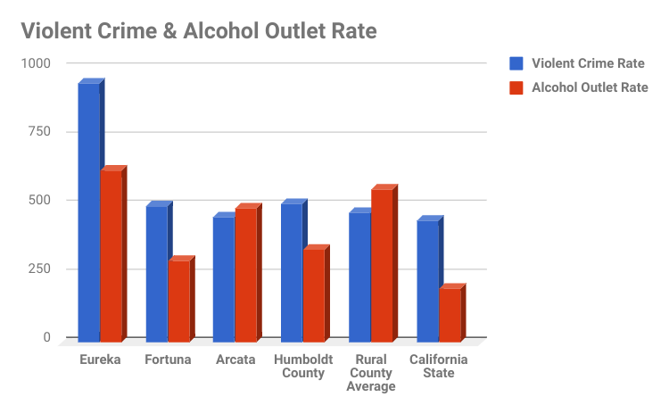
Figure 2 below shows the breakdown of active alcohol permits for Humboldt County as of 12/11/2017 (ABC, 2017). “Off-sale” refers to establishments where the alcohol sold is meant to be consumed off-premise. Examples of this would include grocery and convenience stores. “General” means that the establishment can sell beer, wine and hard alcohol. “Bar” here refers to what the ABC calls “On-Sale Public Premises.” It is an establishment that sells alcohol to be consumed on-premise and does not have to sell food. You must be at least 21 years old to enter the premises. “Tavern” refers to an establishment that also sells alcoholic beverages on-premises, however it must provide sandwiches or other snacks and children are allowed on the premises. “Other” refers to private drinking clubs and other speciality licenses. In Humboldt County, 47.9% of all retail alcohol establishments are restaurants, 34% are off-sale retailers, and 10.4% are bars or taverns.

Figure 2
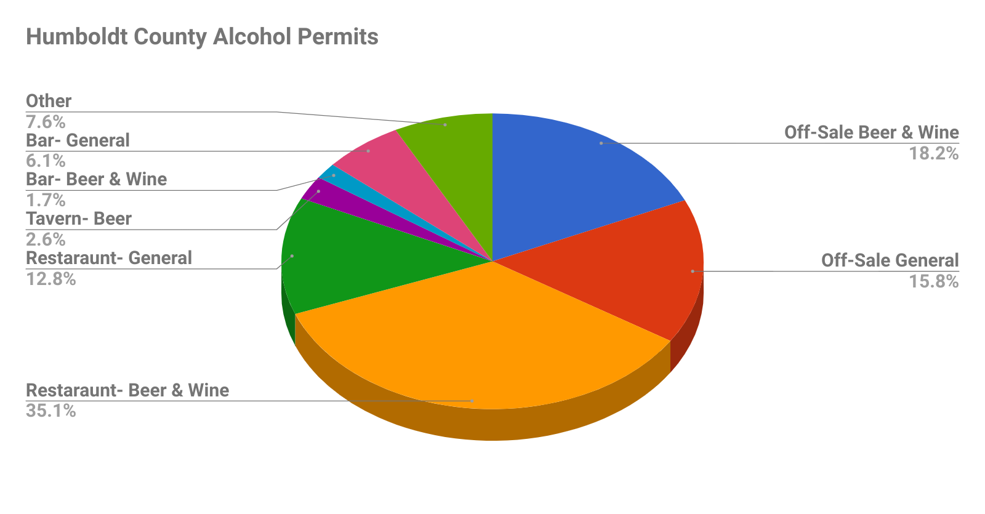
Figure 3 shows the breakdown of the reported Humboldt Crime Data for the year 2016 (FBI, 2017). In that year there were 682 total violent crimes, 12 murders (including nonnegligent manslaughter), 62 rapes, 167 robberies and 441 aggravated assaults. All definitions for violent crime come from the FBI Uniform Crime Reporting Statistics.
Figure 3: Humboldt County Violent Crimes
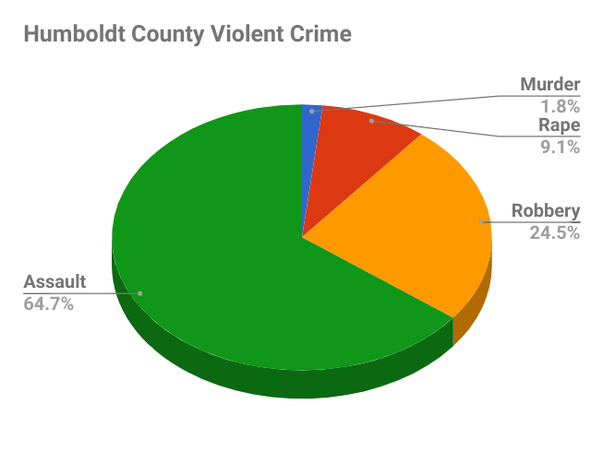
Figures 4, 5 and 6 below show concentrations of alcohol outlets (ABC, 2017) and violent crime. Figure 4 documents violent crime and alcohol outlet data for Arcata in the year 2016 and Figure 5 documents violent crime and alcohol outlet data for Arcata in 2017 up until August 2017.
Figure 4: Violent Crimes and Alcohol Outlets in Arcata During 2017
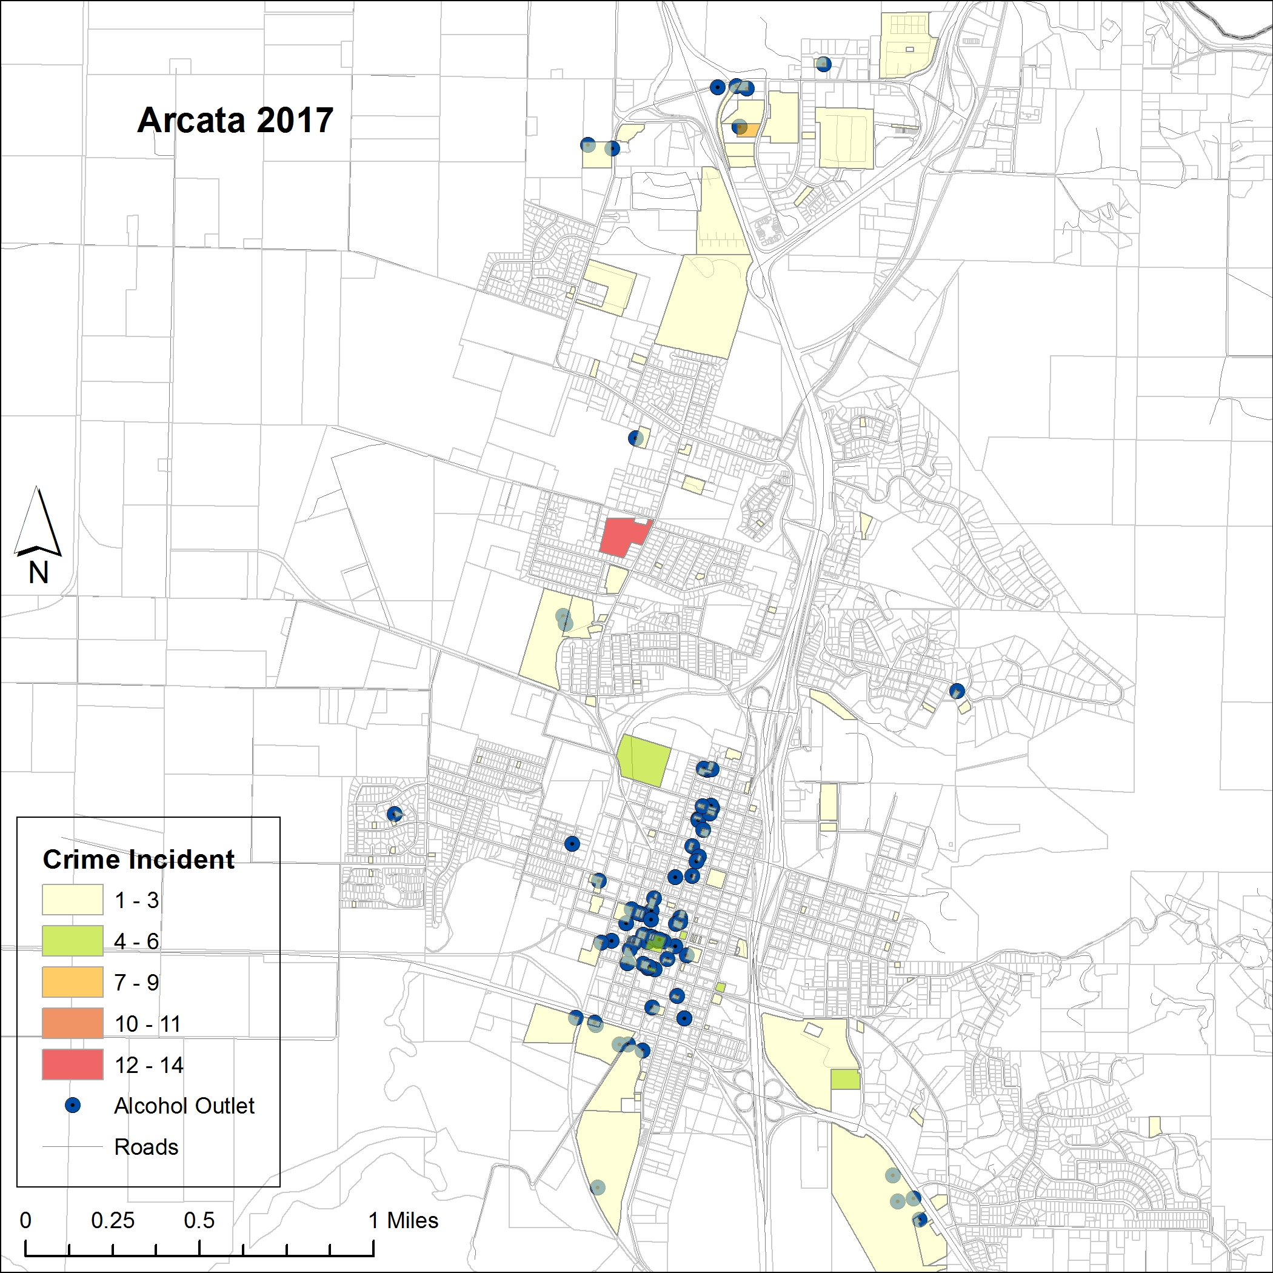

Figure 5: Violent Crimes and Alcohol Outlets in Arcata During 2016
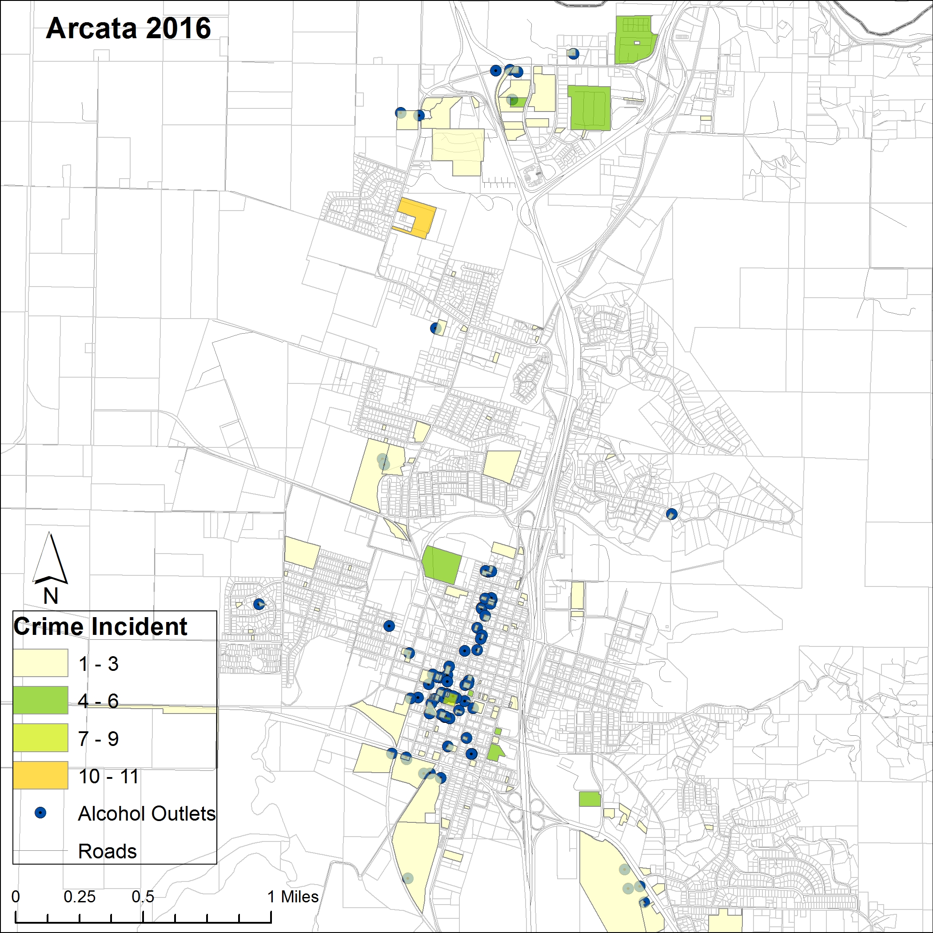

Violent crime and alcohol outlet data for Fortuna is for 2017 up until November 7th is depicted in Figure 6. For the Fortuna data, the crime data is color coded to the roads, rather than to city blocks like it is for the Arcata data, due to the layers publicly available from the Humboldt GIS website.
Figure 6: Fortuna Violent Crimes and Alcohol Outlets

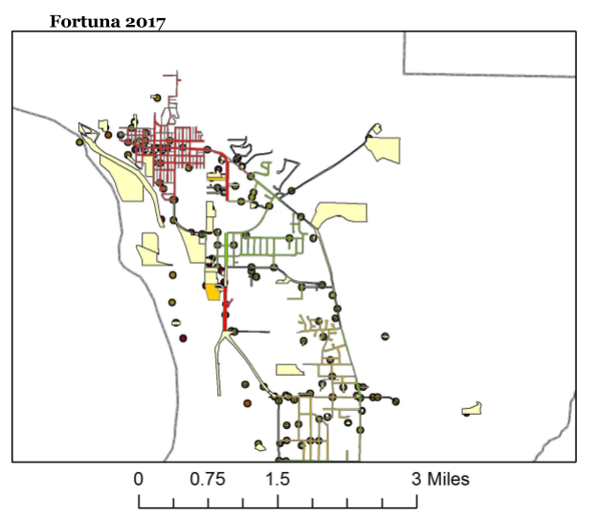

Critical Interpretation and Discussion
Based on the preliminary results of the research, there may be a correlation between alcohol outlets and instances of violent crime in both Arcata and Fortuna, CA. In both cities, instances of crime are more common in areas where there are multiple alcohol outlets, both on sale and off sale. It is important to note that, due to the rural nature of the community, the results could be skewed due to more people living in these areas and few people living on the outskirts of town. Additionally, there are many people who are considered to be transient who stay in the area of Arcata where the majority of alcohol outlets are located. This study did not take into account the demographics or socio-economic atmosphere of the community.
The initial research mimics previous studies that have looked at instances of violent crime around alcohol outlets. The CDC released a report stating that excessive alcohol use results in higher rates of violent crime (Shimotsu, Jones-Webb, Nelson, MacLehose, 2012). The initial results seem to follow the trend that Gruenewald et. al (2006) found in their analysis of 1,637 zip codes in California. This study found that alcohol outlets directly contribute to instances of violent crime in communities that are already prone to violent crime.
The results in Arcata and Fortuna are comparable to the study completed in rural New Zealand. The study found that violent crime was more likely to be found in close proximity to alcohol outlets (Day, Breetzke, Kingham, & Campbell 2012). Our initial results seem to mimic the results of the New Zealand study, with more clusters of violent crime being found in Arcata and Fortuna in close proximity to alcohol outlets.
Additionally, the research is comparable to the research completed in Virginia that shows alcohol availability is a strong predictor of violent crime. It is important to note that in this study, alcohol availability did not contribute to violent crime in the downtown area. The opposite was found in both Arcata and Fortuna, with violent crime being found primarily in the downtown areas. Several factors may contribute to the difference in findings. The study in Virginia was done in an urban area and the majority of alcohol outlets in the downtown area were restaurants where people do not go primarily to drink (White, Gainey, & Triplett, 2015). In Arcata and Fortuna, the opposite is true. Both towns have downtown areas that consist of restaurants, bars, and liquor stores.
This research is relevant to Humboldt County as it is a rural community with high rates of violent crime, as there has been limited research thus far. Additionally, as Houston (2017) points out, Humboldt County has high instances of alcohol related overdoses and underage drinking. Gurrman (2017) states that rates of murder and nonnegligent manslaughter are highest in Humboldt County. Further research on the relationship between alcohol outlets and violent crime would benefit Humboldt County by helping to drive public policy to increase community safety that does not point fingers at factors such as socioeconomic and/or minority status.
More research is needed in this topic before the results could be applied to policy changes within the community. However, initial research indicates that changes in policy around rules and regulations that govern alcohol outlets may be beneficial to the community. Policy changes that have been used in other communities include a one percent increase in alcohol price, a one hour change in closing times of alcohol outlets, and limiting the number of permits issued to both on and off sale alcohol outlets based on populations density (Fitterer, Nelson, & Stockwell, 2015).
Recommendations
One of the primary concerns with doing spatial analysis is that the publicly available data available for Fortuna was linked to streets as a means of organization. One of our recommendations would be to work with a GIS expert in addition to governmental or contract GIS mappers in order to get more specific population data in order to separate the crime data from the parcels as organized by streets. Due to the fact that our data was organized entirely through spatial access-based data, there are limited mathematical correlations that can be computed from this data, without accounting for the square footage of each alcohol outlet. Although there is a “visual” correlation in the mapping data, any spatial based analytical conclusions would be flawed due to the irregular spacing characteristics of a rural area (Bhaduri, Bright, Coleman & Urban, 2007). Further, as discussed in the CDC’s guide for evaluating alcohol outlet density, it would require an analyst with technical expertise in GIS software (Sacks, Gruenewald & Roeber, n.d.) and access to more rigorous population data, such as through LandScan™ (Bhaduri et. al 2007). For example, by using LandScan, we would be able to more accurately compile population data. This is particularly important in areas with a variable population rate which could be not necessarily reflected in US Census data. Due to these limitations, we would recommend a container-based measurement tool be used for further research. As stated by the CDC, this would facilitate more conclusive data, and the ability to measure additional factors, such as evaluating harms, the populations directly exposed, and clustering patterns (Sacks, et. al., n.d.).
Additionally, we concur with Fitter et. al (2015) that further research should be done using population measurements smaller than census tracts. This is particularly important in small rural areas, with a transient population flow that might not be accurately represented in the census. In order to validate the violence rates, we would recommend cross referencing the violence rates with hospital discharge statistics, such as in the research from Grunewald et. al.
Moreover, we recommend further work in collaboration with each of the individual police departments of Humboldt county, particularly Eureka. As discussed earlier, Eureka is known to have a higher concentration of both bars and crime rates. For example, according to the ABC, the Eureka zip code of 02215 has 132 alcohol outlets (ABC, 2017). However, we were unable to access yearly crime data at the time of publication. If the trends are found to be consistent in Eureka as well, then there are clear policy measures that can be addressed in order to reduce the violent crime rates. Fitterer et. al (2015) recommends that limiting alcohol outlet density to less than 25 outlets per postal code will assist in reducing crime. Moreover, small policy changes have demonstrated a significant result in a reduction of violent crime rates. They note available options such as increasing alcohol price by 1%, an hour reduction closing times in outlets or reducing alcohol outlet density, all which have been demonstrated to have a significant effect (Fitterer et. al, 2015). These policy suggestions are feasible steps for reducing crime rates in Humboldt County. Equally important, as Gruenewald and Remer (2006) found that lower income and greater percentage of minority demographics were more likely to be exposed to increased rates of violence, these are policy recommendations that social workers should advocate for, as well.

References
Bhaduri, B., Bright, E., Coleman, P., & Urban, M. (2007). LandScan USA: A high-resolution geospatial and temporal modeling approach for population distribution and dynamics. GeoJournal., 69(1-2), 103-117.
California Department of Alcoholic Beverage Control. (2017). License Query System- Reports. Retrieved (2017 December 11) from https://www.abc.ca.gov/datport/lqs.html?menu=main
California Legislative Information. PEN. Retrieved November 11, 2017, from https://leginfo.legislature.ca.gov/faces/codesTOCSelected.xhtml?tocCode=PEN&tocTitle=%2BPenal%2BCode%2B-%2BPEN
City of Arcata Police Department. (2017). Crime Records. Received (2017 November 16) from Arcata Police Business Manager
City of Fortuna Police Department. (2017). Crime Records. Received (2017 November 9) from Communications Supervisor.
Day, P., Breetzke, G., Kingham, S., & Campbell, M. (2012). Close proximity to alcohol outlets is associated with increased serious violent crime in New Zealand. Australian and New Zealand Journal of Public Health, 36(1), 48–54. https://doi.org/10.1111/j.1753-6405.2012.00827.x
Dixon, M. A., & Chartier, K. G. (2016). Alcohol Use Patterns Among Urban and Rural Residents: Demographic and Social Influences. NCBI. Retrieved September 26, 2017, from https://www.ncbi.nlm.nih.gov/pmc/articles/PMC4872615/
Fitterer, J. L., Nelson, T. A., & Stockwell, T. (2015). A Review of Existing Studies Reporting the Negative Effects of Alcohol Access and Positive Effects of Alcohol Control Policies on Interpersonal Violence. Frontiers in Public Health, 3. https://doi.org/10.3389/fpubh.2015.00253
Gruenewald, P. J., Freisthler, B., Remer, L., LaScala, E. A., & Treno, A. (2006). Ecological models of alcohol outlets and violent assaults: crime potentials and geospatial analysis. Addiction, 101(5), 666–677. https://doi.org/10.1111/j.1360-0443.2006.01405.x
Health Resources & Services Administration. (2016, December 31). List of Rural Counties And Designated Eligible Census Tracts in Metropolitan Counties. Retrieved December 10, 2017, from https://www.hrsa.gov/sites/default/files/ruralhealth/resources/forhpeligibleareas.pdf
Jennings, J. M., Milam, A. J., Greiner, A., Furr-Holden, C. D. M., Curriero, F. C., & Thornton, R. J. (2014). Neighborhood Alcohol Outlets and the Association with Violent Crime in One Mid-Atlantic City: The Implications for Zoning Policy. Journal of Urban Health, 91(1), 62–71. https://doi.org/10.1007/s11524-013-9821-z
Livingston, M. (2008). Alcohol outlet density and assault: a spatial analysis. Addiction, 103(4), 619–628. https://doi.org/10.1111/j.1360-0443.2008.02136.x
Pridemore, W. A., & Grubesic, T. H. (2013). Alcohol Outlets and Community Levels of Interpersonal Violence: Spatial Density, Outlet Type, and Seriousness of Assault. Journal of Research in Crime and Delinquency, 50(1), 132-159. DOI: 10.1177/0022427810397952
Redwood Memorial Hospital. (2014). Community Health Needs Assessment Report. Retrieved from https://www.stjoehumboldt.org/documents/2014-Community-Health-Needs-Assessment-Report.pdf
Sacks, J. J., Gruenewald, P. J., & Roeber, J. (n.d.). Guide for Measuring Alcohol Outlet Density. https://www.cdc.gov/alcohol/pdfs/CDC-Guide-for-Measuring-Alcohol-Outlet-Density.pdf
Shimotsu, S. T., Jones-Webb, R. J., Nelson, T. F., MacLehose, R. F., Lytle, L. A., Forster, J. L., & Van Riper, D. C. (2012). Food and Alcohol Access in Neighborhoods of Varying Socioeconomic Status. Journal of Alcohol and Drug Education; Lansing, 56(3), 77–92.
United States Census Bureau. (2016). Quick Facts: Humboldt County, California. Retrieved (2017 December 11) from https://www.census.gov/quickfacts/fact/table/humboldtcountycalifornia,humboldtcountyiowa,eurekacitycalifornia/PST045216
United States Department of Justice, Federal Bureau of Investigation. Violent Crime. (2011, July 25). Retrieved October 03, 2017, from https://ucr.fbi.gov/crime-in-the-u.s/2010/crime-in-the-u.s.-2010/violent-crime
United States Department of Justice, Federal Bureau of Investigation. (2017, June 23). Crime by County 2016. Retrieved (2017 December 11) from the FBI Uniform Crime Report.
White, G. F., Gainey, R. R., & Triplett, R. A. (2015). Alcohol Outlets and Neighborhood Crime: A Longitudinal Analysis. Crime & Delinquency, 61(6), 851–872. https://doi.org/10.1177/0011128712466386
Zhang, X., Hatcher, B., Clarkson, L., Holt, J., Bagchi, S., Kanny, D., & Brewer, R. D. (2015). Changes in Density of On-Premises Alcohol Outlets and Impact on Violent Crime, Atlanta, Georgia, 1997–2007. Preventing Chronic Disease, 12. https://doi.org/10.5888/pcd12.140317

Acknowledgements
Special thanks to the police department managers at the cities of Fortuna and Arcata for providing their violent crime data. Additional thanks to our GIS consultant, Robert Bergeson for the maps. And last but not least, to Connie Stewart for the topic idea and Pam Bowers, Phd. for the mentorship, guidance & support with the IRB application.

