California Jobs First: Project Readiness
California Jobs First will invest up to $450 million statewide ($162M in the Predevelopment Phase and $268M in the Implementation Phase) in projects that support a community-led, climate-forward economy. Through the Predevelopment Phase, each region will develop a portfolio of projects designed to attract additional federal, state, and private investment while building the economy envisioned by each California Jobs First Regional Collaborative (formerly HRTC). Implementation Phase investments will fund projects that directly support the investment strategies identified in each Regional Plan.

Stages of project readiness
Projects are divided into stages of readiness. Criteria for each stage are defined below.
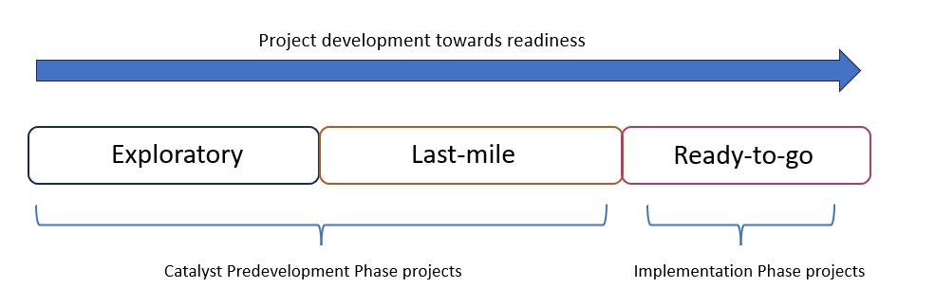
Regional Collaboratives may direct Predevelopment Phase funding to projects meeting the criteria of ‘exploratory’ or ‘last-mile’ with the intention of developing them towards ‘ready-to-go.’ All projects identified as ‘ready-to-go’ by June 2024 will be eligible to submit proposals for California Jobs First Implementation Phase funds or other relevant funding sources. Since all California Jobs First contracts must be completed by September 2026, the scope of the deliverables and outputs for each phase must be based on what is feasible to complete within the period of performance.
At all stages of readiness, Predevelopment and Implementation project proposals will need the following to be considered eligible:
- Project overview, with objectives, scope, workplan with timeline, and budget
- Identified service or benefits recipients
- Project sponsor
- Project team (internal staff and external partners)
- Community partnerships
- Potential risks to project’s implementation or delivery of successful outcomes
- Approval by California Jobs First Regional Collaborative (formerly HRTC)
- Explicit alignment with California Jobs First Regional Plans
- Clear explanation of what grantee will deliver by end of grant, and clear explanation of what project success looks like and how success will be measured
- Be able to be completed within the expenditure deadline of September 2026, or have phases that are able to be completed within this timeframe
Ready-to-go projects have completed all necessary and possible steps to be ready for implementation upon receiving funding. To be considered ready-to-go, projects should have:
- Completed necessary plans or studies such as but not limited to: needs assessment, business plan, feasibility study, environmental assessment, site plan, preliminary engineering report, management plan, community outreach and engagement plan, or other plan or study necessary for the success of the project. The required plans or studies will depend in part on whether the project is a capital (construction) project or not.
- Additional funding sources secured or soon-to-be secured, if applicable
- Construction projects must include the following:
  - Proof of site control
  - Preliminary permitting and approvals: list of required permits, approvals, etc. to build the project and timeline of when they have been acquired or expect to be acquired
  - Additional criteria as defined by the Interagency Team (anticipated release in Winter 2024)
Last-mile projects have completed feasibility assessments and are considered feasible and viable projects to achieve their stated objectives. These projects have undergone initial steps towards development and must clear a few additional hurdles (e.g. site selection, permitting, environmental review) before being considered ready-to-go. Last-mile projects should have:
- Completed feasibility study if applicable
- Some necessary plans or studies completed such as but not limited to: needs assessment, business plan, environmental assessment, site plan, preliminary engineering report, management plan, community outreach and engagement plan, or other plan or study necessary for the success of the project
- Potential funding sources identified
Exploratory projects are in the early stages of development. They may be an idea or a back-of-the-envelope plan and may need dedicated funding to study and develop into potential projects and conduct feasibility assessments. There are no additional requirements of exploratory projects other than the basic requirements for all projects described above.

Resources
- Milken Institute Predevelopment Guide (click “Open The Report” at the bottom of the page)
- Community Infrastructure Center Predevelopment 101
- HR&A Advisors Infrastructure Funding Navigator

